**ABCs of using Git Hub**

**Introduction**

Clone, push, pull and commit are the basic commands for using git hub. Clone is used for the initial copying of files into an empty folder. Commit is for selecting files to put copied to Git hub. Push is to copy files back to Github, and Pull is to retrieve and update files that have been changed.

**Cloning an Repository**

Clone is used clone or copy a repository into an empty directory. Cloning is primary used to fill an empty directory with files from a project on Git Hub. Clone will not work on a folder that contains any files.

To clone a git hub project, (repository) (figure 1) the URL is needed from the Git Hub web page. This link is listed in the SSH panel, after selecting Project.

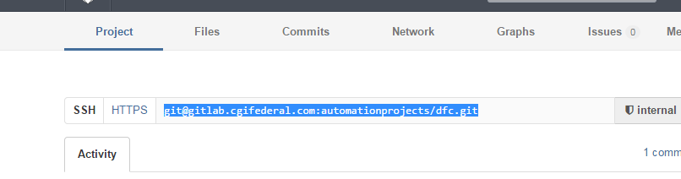

Figure Location of Git Hub URL

Copy and Paste the SSH URL and paste it in the URL box, after clicking Clone, verify the destination of the files in the directory field, and pick a branch, usually development. When everything is correct, click OK. This will transfer the files from the Git Hub URL to the directory specified in the directory field.

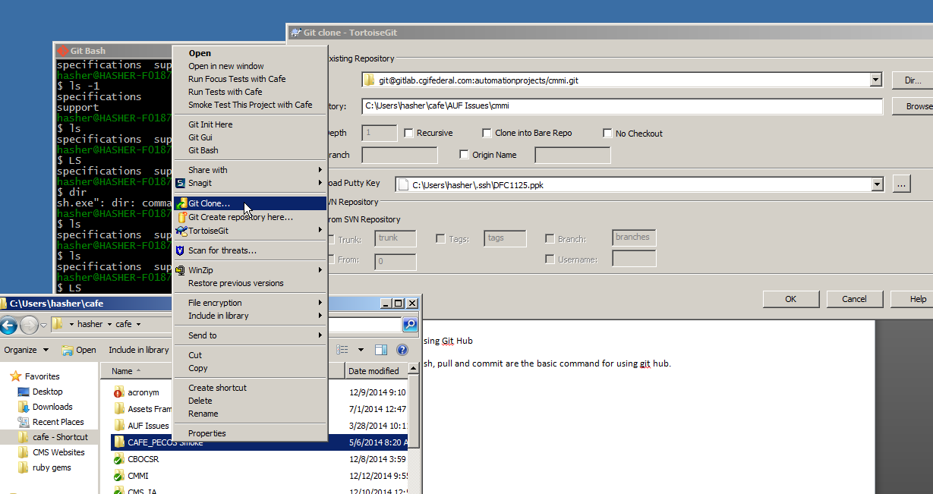

Figure URL and Directory for Cloning

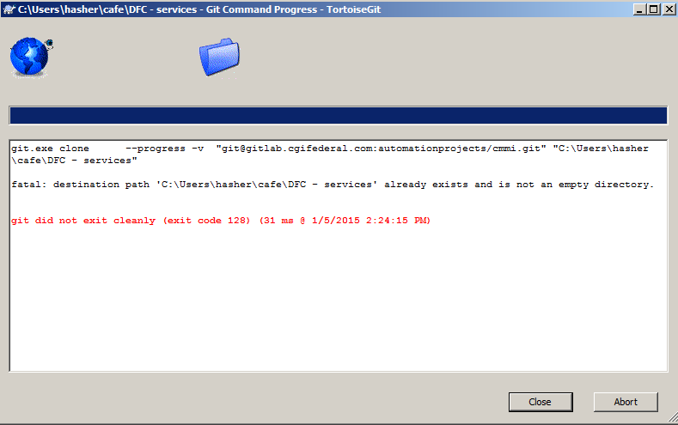

Figure Failed Cloning Operation

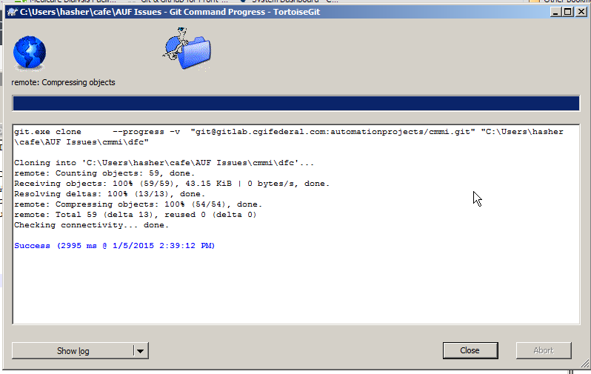

Figure Successful Cloning

**Committing Files**

The processing of selecting files to be transferred to Git Hub server is called commit. The committed files are not copied (pushed) to the server just marked to be transferred or pushed to the server. Files can be committed to be deleted, to be updated or to be added to the git hub server. The actual action occurs during the push operation. Figure 5 shows a deleted file, a changed file and an added file, this is indicated by the Status Column. New files are Not Versioned Files, and have to be checked to be added. Other Operations such as deletion or file updating can be cancelled by unchecking the box on the right hand side of the filename.

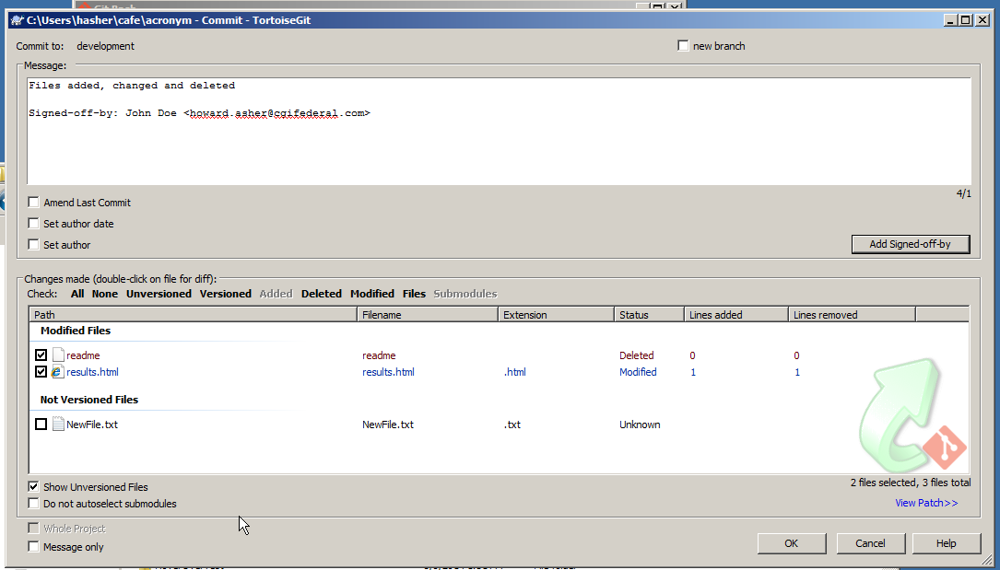

Figure Commit operation showing Deletion, Updating, and Adding new file

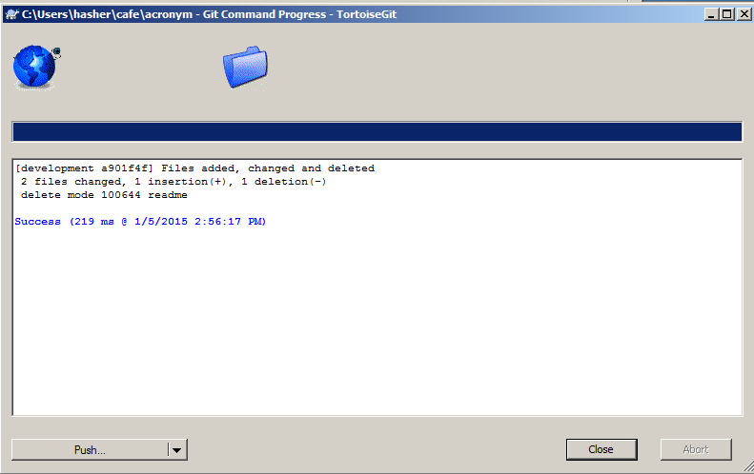

Figure Successful Commit Operation

Pushing Files

After the commit operations is completed click on the Push button on the commit page. Vertify that that remote says development, and if everything has been setup correctly Local should indicate development.

